Ngô Thị Kim Duyên

December 4, 2024

system Requirement specification

demo my web – version 2.0

# E-commerce

## UC1: Buy Product

**Basic flow**

|  |  |
| --- | --- |
| **1** | User access to the system |
| **2** | The system displays all products on the home page |
| **3** | The user chooses a product and clicks the buy button |
| **4** | The number of carts updated on top header |
| **5** | The flow end |

**Mock-up screen:**

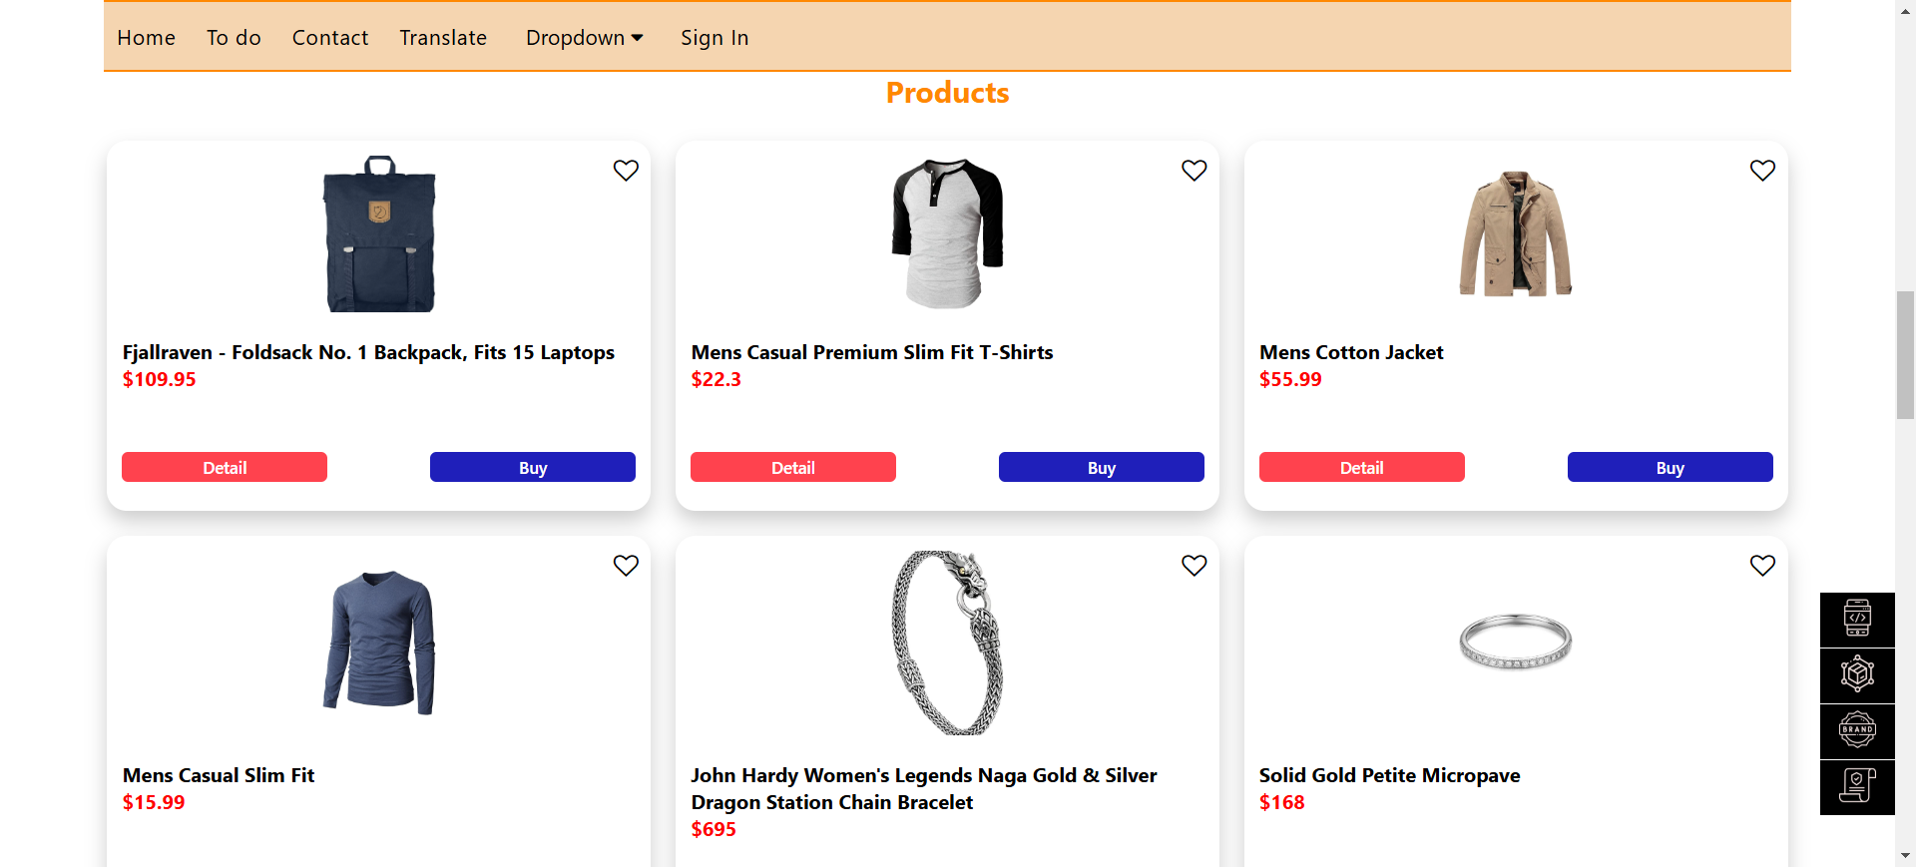

**Business rule:**

|  |  |
| --- | --- |
| **BR-1** | User can buy the same items and the number of items will increase n quantity and the total price is changed in the cart |
| **BR-2** | User can buy different items and each item only has 1 quantity. |

## UC2: Calculate Cart

**Basic flow**

|  |  |
| --- | --- |
| **1** | The user clicked buy some products |
| **2** | The user clicks the cart icon on the top header |
| **3** | The system shows the cart page |
| **4** | The user fills in customer information and clicks the checkout button |
| **5** | The user orders successfully and navigates the checkout page |
| **6** | The user clicks back to home button |

**Exception flow (The user doesn’t buy the product)**

|  |  |
| --- | --- |
| 1 | The user clicks the cart icon on the top header |
| 2 | The system shows the cart page |
| 3 | The user clicks the clear cart button and back to the home page |
| 4 | The flow end |

**Mock-up screen**

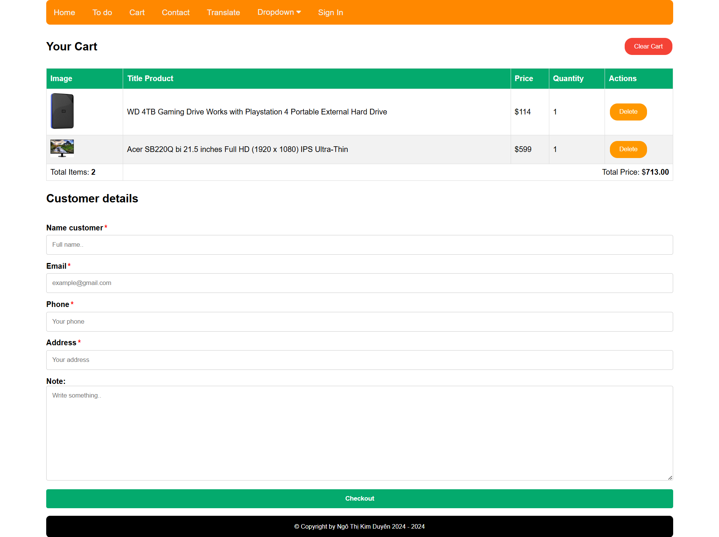

**Business rule:**

|  |  |
| --- | --- |
| **BR-3** | The user doesn’t click buy an item, user can’t navigate the checkout page |
| **BR-4** | User doen’t fill form customer detail. The system displays an error message ME001: “All fields are required!” |
| **BR-5** | User inputs name less than 2 words. The system displays an error message ME002: “The username must be more than one word” |
| **BR-6** | User inputs email address must be correct format. If not, display the error message ME003: “The email address is invalid” |
| **BR-7** | User inputs phone less than 10 digits. If the user doesn’t, display the error message ME004:”Phone number must be 10 digits” |
| **BR-8** | User doen’t input the address. The system displays an error message ME005:”The address is invalid” |

## UC3: Checkout Products

**Basic flow**

|  |  |
| --- | --- |
| 1 | The user clicks the checkout button on the cart page |
| 2 | The system navigates to the checkout page |
| 3 | The user clicks the back to home button |
| 4 | The system navigates to the home page |
| 5 | The flow end |

**Mock-up screen**

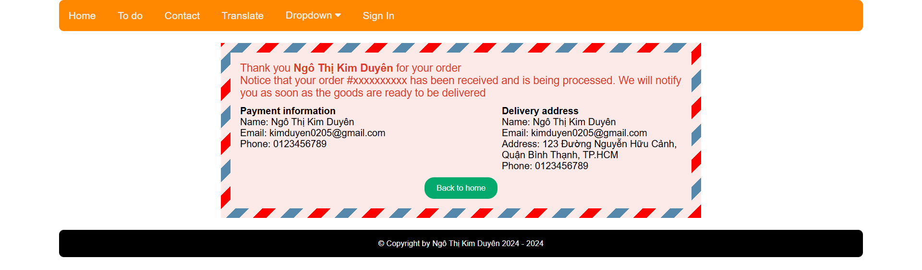

## UC4: Detail Product

**Basic flow**

|  |  |
| --- | --- |
| 1 | User access to the system |
| 2 | The system displays all products on the home page |
| 3 | The user chooses an item and clicks the detail button |
| 4 | The system shows content detail |
| 5 | The user clicks the close icon to exit the detail |
| 6 | The flow end |

**Mock-up screen**

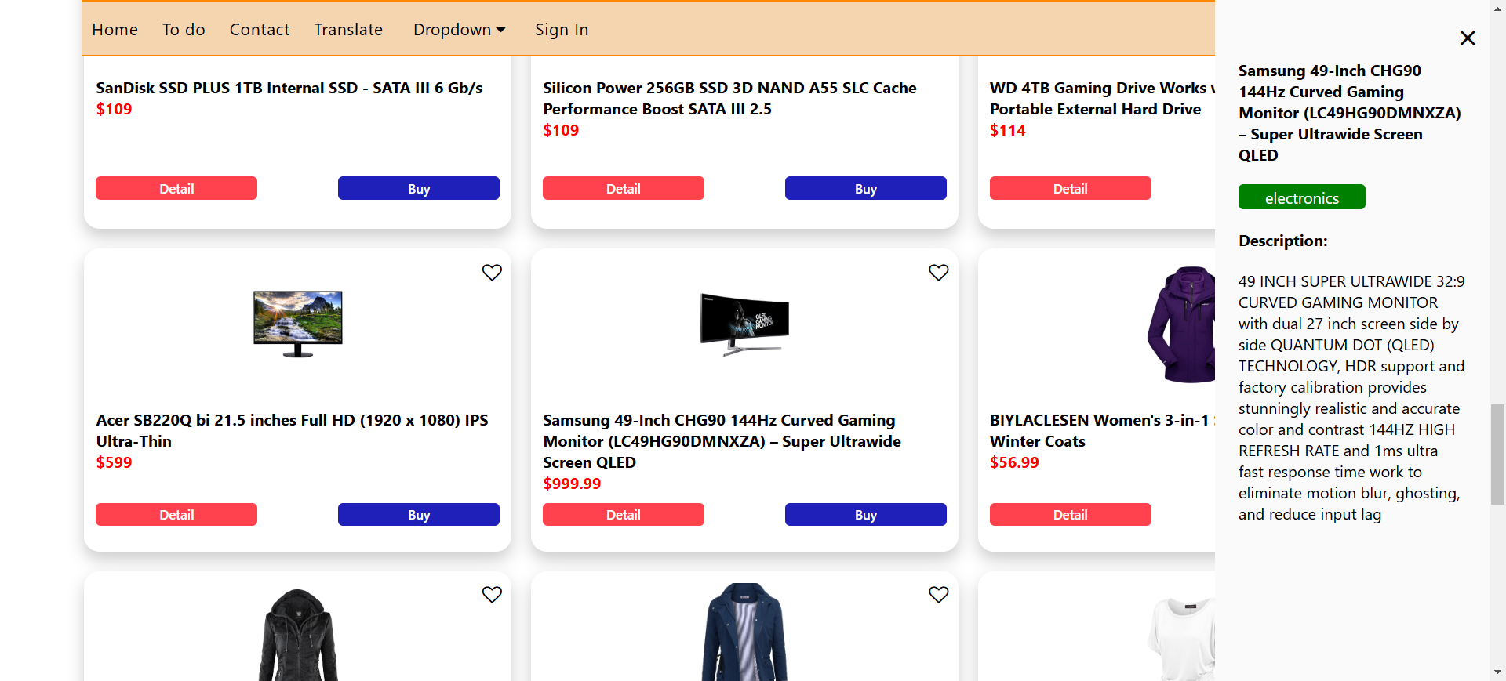

## UC5: Like Product

**Basic flow**

|  |  |
| --- | --- |
| **1** | User access to the system |
| **2** | The system displays all products on the home page |
| **3** | The user chooses a product and clicks one time the heart icon |
| **4** | The number of likes updated on top header |
| **5** | The flow end |

**Exception flow (The product is unlike)**

|  |  |
| --- | --- |
| **1** | User access to the system |
| **2** | The system displays all products on the home page |
| **3** | The user chooses a product and clicks the heart icon again |
| **4** | The number of hearts updated on top header |

**Mock-up screen**

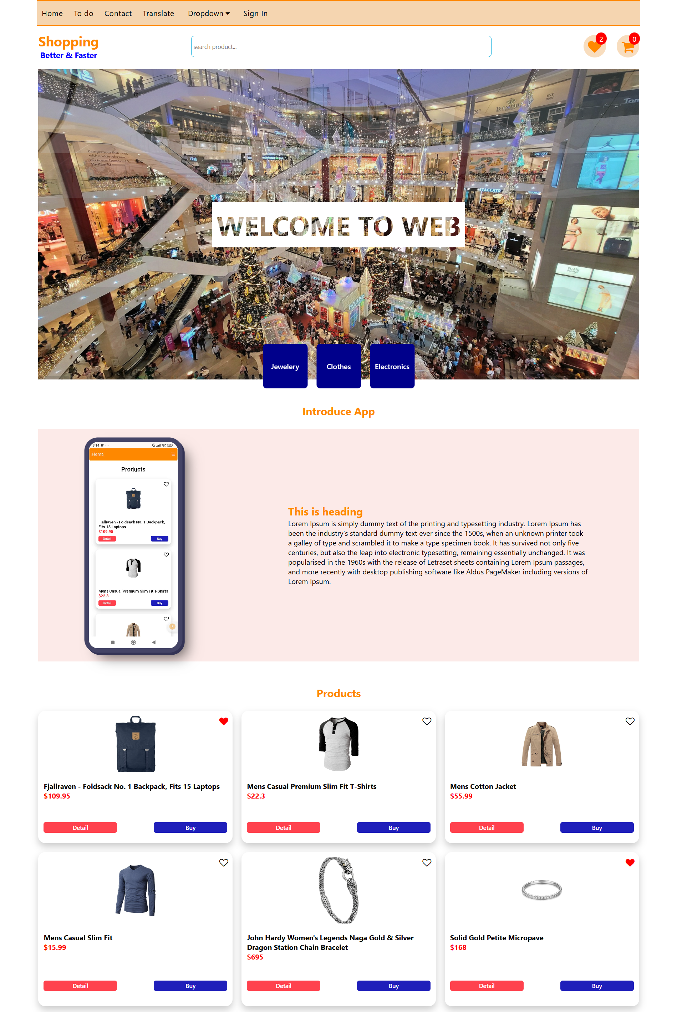

## UC6: Delete Product

**Basic flow**

|  |  |
| --- | --- |
| 1 | The user clicks the cart icon in home page |
| 2 | The system shows the cart page |
| 3 | The user chooses an item and clicks delete button |
| 4 | The cart table is updated total items and total price |

**Mock-up screen**

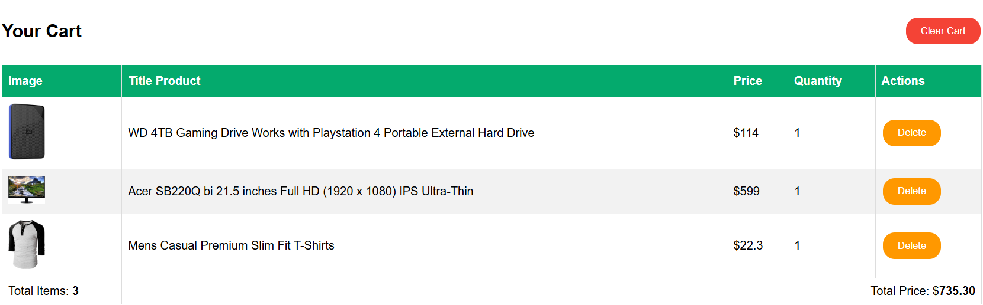

Figure 1 Before click delete button

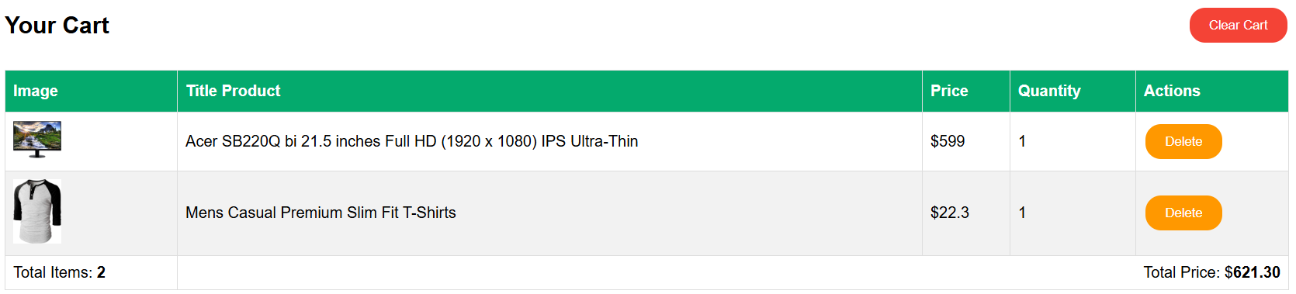

Figure 2 After click delete button

## UC7: Clear Cart

**Basic flow**

|  |  |
| --- | --- |
| **1** | The user clicks the cart icon on the home page |
| **2** | The system shows the cart page |
| **3** | The user clicks the clear cart button |
| **4** | All items are removed from the table and back to the home page |

**Mock-up screen**

Figure 3 Before click clear cart

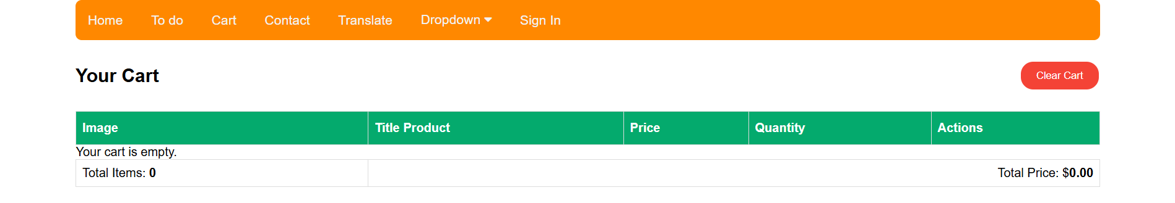

Figure 4 After click clear cart

## UC8: Search Product

**Basic flow**

|  |  |
| --- | --- |
| 1 | User access to the system |
| 2 | The user inputs the name of a product or any characters in the search bar |
| 3 | The system displays the results of search product |

**Exception flow**

|  |  |
| --- | --- |
| 1 | The user clicks the “x” icon in the search bar |
| 2 | The system shows all product |

**Mock-up screen**



## UC12: Upload Image

**Basic flow**

|  |  |
| --- | --- |
| **1** | The user clicks the Home item in the menu |
| **2** | The user scrolls down “Reasonable Delivery & Return Policy” and clicks “Section 2” |
| **3** | The user clicks the upload image button |
| **4** | The system shows the dialog box to choose an image |
| **5** | The user chooses any image and clicks open |
| **6** | The system shows an image |
| **7** | The user clicks the image, it will expand the screen |
| **8** | The user clicks the “x” button to close the fullscreen |

**Mock-up screen**

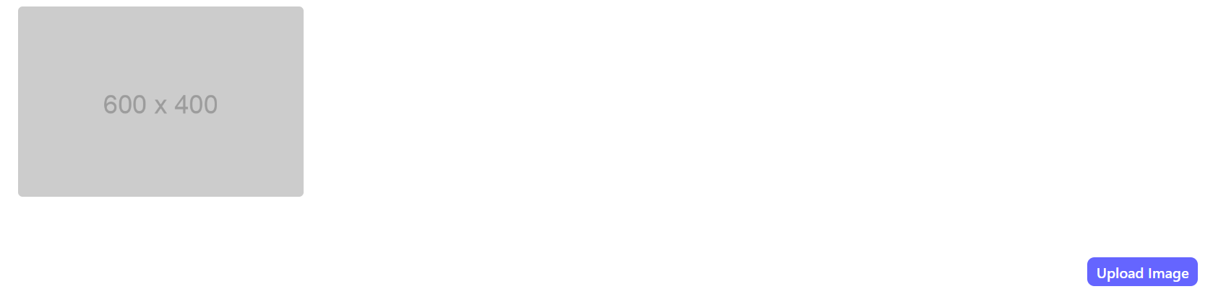

## UC13: Scroll to element

**Basic flow**

|  |  |
| --- | --- |
| **1** | The user clicks the Home item in the menu |
| **2** | The user clicks the first box |
| **3** | The system will scroll to “Introduce App” |
| **4** | The user clicks the second box |
| **5** | The system will scroll to “Products” |
| **6** | The user clicks the three box |
| **7** | The system will scroll to “Product Brands” |
| **8** | The user clicks the four box |
| **9** | The system will scroll to “Reasonable Delivery & Return Policy” |

**Mock-up screen**

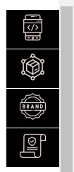

# Contact

**Basic flow**

|  |  |
| --- | --- |
| **1** | User access to the system |
| **2** | The user clicks the contact link in the menu |
| **3** | The system navigates to the contact page |
| **4** | The user inputs some fields |
| **5** | The user clicks the submit button |

**Mock-up screen**

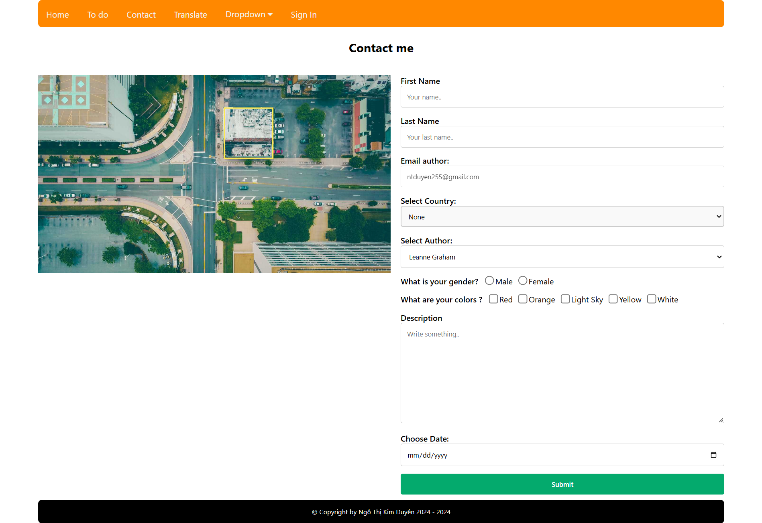

|  |  |
| --- | --- |
| **BR-15** | Click the submit button and all data in each field must be deleted |

# Log in

**Basic flow**

|  |  |
| --- | --- |
| **1** | User access to the system |
| **2** | The user clicks login in the menu |
| **3** | The system shows a login screen |
| **4** | The system validates the account credentials successfully and allows the user to access the system |
| **5** | The user login successfully |
| **6** | The system access dashboard page |

**Exception flow 1 – User fills incorrect email/password**

|  |  |
| --- | --- |
| **Step** | **Description** |
| 1 | The system fails to validate the credentials and returns an error message ME006: “Invalid email or password. Please try again!” |

**Exception flow 2 – Password doesn’t meet the password requirement**

|  |  |
| --- | --- |
| **Step** | **Description** |
| 1 | The system displays an error message ME007: “Password must be at least 8 characters long, contain an uppercase letter, a lowercase letter, a number, and a special character.” to inform the user. |

**Mock-up screen**

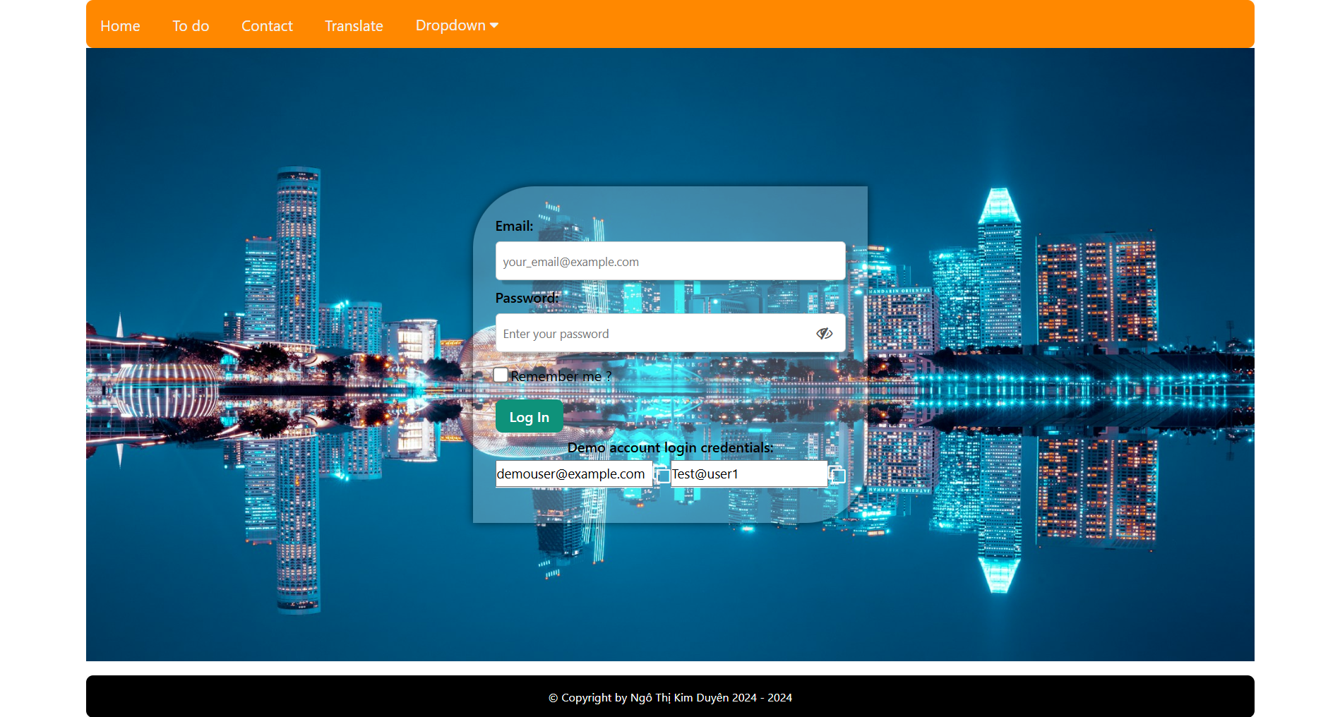

**Business rule:**

|  |  |
| --- | --- |
| **BR-9** | Must have email and password if not, show ME008: “Required field” |
| **BR-10** | The email format is invalid. The system shows an error message ME009: ”Please enter a valid email address.” |
| **BR-11** | The password needs to have 8 characters and be encrypted |
| **BR-12** | Password must be at least 8 characters long, contain an uppercase letter, a lowercase letter, a number, and a special character.” to inform the user |
| **BR-13** | If the user hasn’t logged in, the user isn’t allowed access to the dashboard page. It only goes back to the login page |

# Log out

**Basic flow**

|  |  |
| --- | --- |
| **1** | The user logged in successfully |
| **2** | The system shows the dashboard page |
| **3** | The user clicks log out on the menu |
| **4** | The system shows pop-up question |
| **5** | The user clicks Ok button |
| **6** | The system goes to the login page |

**Exception flow 1**

|  |  |
| --- | --- |
| **1** | The user clicks the cancel button |
| **2** | The system is closed pop-up and it is still the dashboard page |

**Exception flow 2:**

|  |  |
| --- | --- |
| **1** | The user clicks the “x” button |
| **2** | The system is closed pop-up and it is still the dashboard page |

**Mock-up screen**

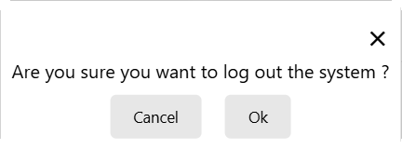

Figure 5 Notification log out

**Business rule:**

|  |  |
| --- | --- |
| **BR-14** | The system deletes data from the user if the user clicks the “Ok” button and goes back to the login page |

# Copy data account

**Basic flow**

|  |  |
| --- | --- |
| **1** | User access to the system |
| **2** | The user clicks login in the menu |
| **3** | The system shows a login screen |
| **4** | The user clicks the icon username copy |
| **5** | The system shows a “copied username” |
| **6** | The user pastes to the username field |
| **7** | The user clicks the icon password copy |
| **8** | The system shows a “copied password” |
| **9** | The user pastes to the password field |

**Mock-up screen**



Figure 6 Copy username account

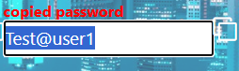

Figure 7 Copy password account

# Translate multiple language

**Basic flow**

|  |  |
| --- | --- |
| **1** | User access to the system |
| **2** | The user clicks the translate link in the menu |
| **3** | The user clicks the Vietnamese button to translate the language Việt Nam for the web default English language |
| **4** | The user clicks the English button to translate the language English for the web default Vietnamese language |

**Mock-up screen**

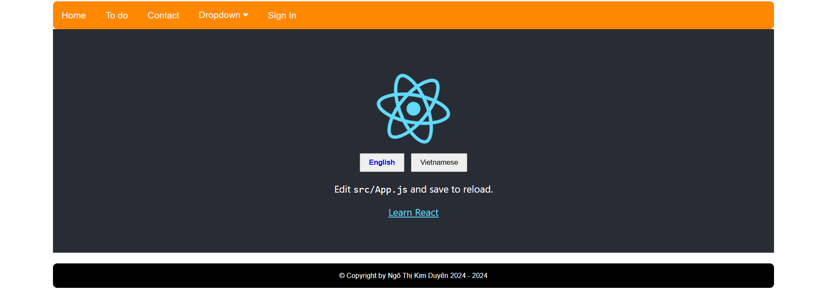

# To-do list

## UC1: Add Items

**Basic follow:**

|  |  |
| --- | --- |
| **1** | User access to the system |
| **2** | The user clicks the “to do” item in the menu |
| **3** | The system shows the “to do” page |
| **4** | The user inputs the editor |
| **5** | The user clicks the add button |
| **6** | The system shows data in the table |

**Exception flow**

|  |  |
| --- | --- |
| **1** | The user inputs the editor |
| **2** | The user clicks the cancel button |

**Mock-up screen**

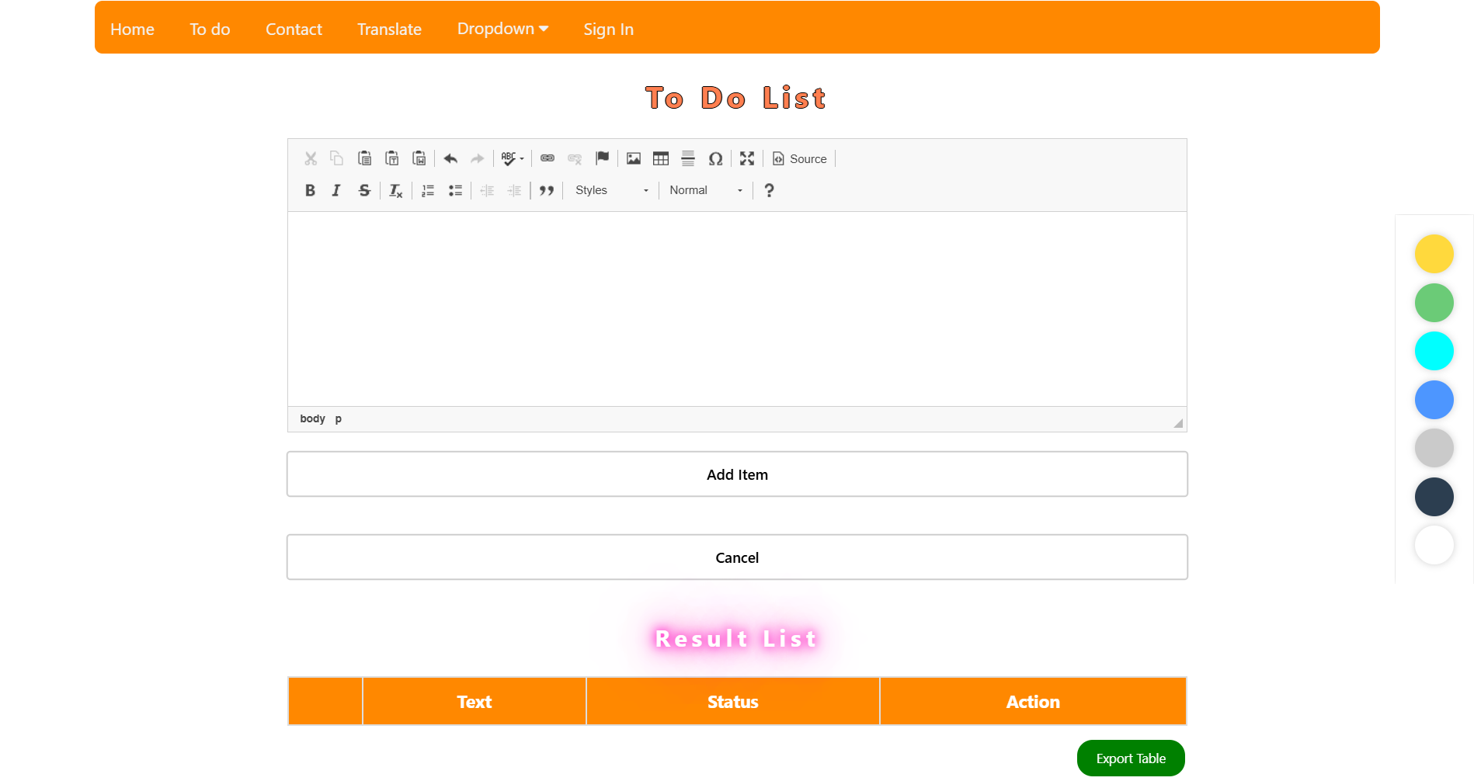

**Business rule**

|  |  |
| --- | --- |
| **BR-16** | When the user doesn’t input text in the editor, the user clicks the add button. The system shows an error message ME009: “You must write something!” |
| **BR-17** | When the user clicks the add button, the data is inserted in the table and the editor is blank |
| **BR-18** | When the user clicks the cancel button, the editor is blank |
| **BR-19** | When the user created data in the table, the status is “To do” |

## UC2: Delete Item

**Basic flow**

|  |  |
| --- | --- |
| **1** | The user chooses an item and clicks the delete button |
| **2** | The system shows a pop-up |
| **3** | The user clicks the Ok button |
| **4** | The system removes an item and closes the pop-up |

**Exception flow 1:**

|  |  |
| --- | --- |
| **1** | The user chooses an item and clicks the delete button |
| **2** | The system shows a pop-up |
| **3** | The user clicks the Cancel button |
| **4** | The system closed the pop-up and it still keeps data in the table |

**Exception flow 2:**

|  |  |
| --- | --- |
| **1** | The user chooses an item and clicks the delete button |
| **2** | The system shows a pop-up |
| **3** | The user clicks the “x” button |
| **4** | The system closed the pop-up and it still keeps data in the table |

**Mock-up screen**

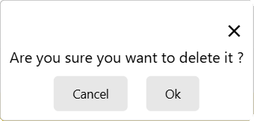

## UC3: Update status

**Basic flow**

|  |  |
| --- | --- |
| **1** | The user clicks the checkbox on a row in the table |
| **2** | The system will strikethrough the text in the table |

**Exception flow**

|  |  |
| --- | --- |
| **1** | The user clicks the checkbox in a row |
| **2** | The system will strikethrough the text in the table |
| **3** | The user clicks again the checkbox in that row |
| **4** | The system will remove the dash on the text |

**Mock-up screen**

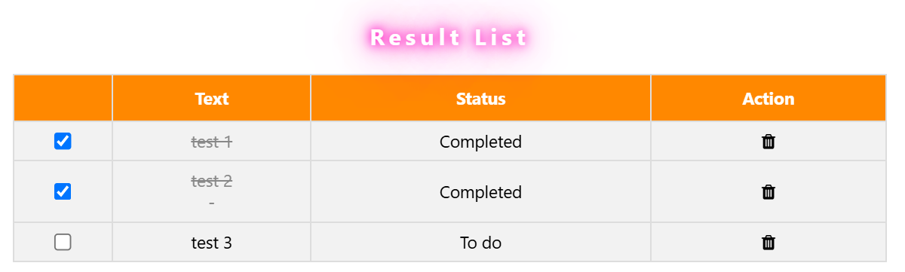

**Business rule**

|  |  |
| --- | --- |
| **BR-20** | When the user clicks the checkbox, the status is updated to “Completed” |

## UC4: Export file

**Basic flow**

|  |  |
| --- | --- |
| **1** | The user clicks the export table button |
| **2** | The system will output an Excel file in the user's computer |

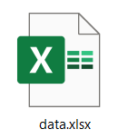

**Mock-up screen**

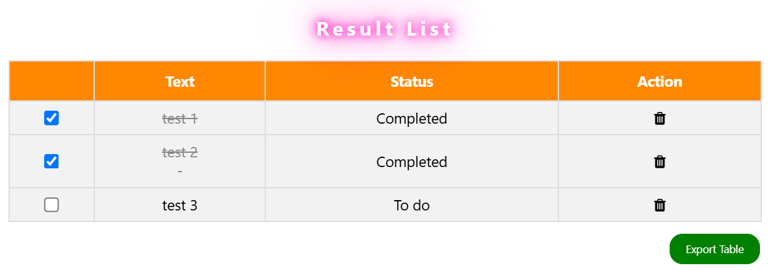

## UC5: Tabs form

**Basic flow**

|  |  |
| --- | --- |
| **1** | The user clicks the “to do” item in the menu |
| **2** | The system shows the “to do” page |
| **3** | The user clicks each tab and fills in the form |

**Mock-up screen**

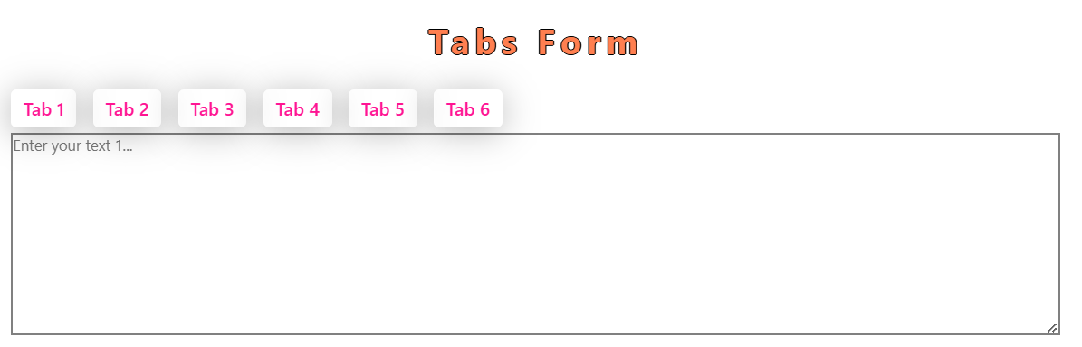

## UC6: Change color background

**Basic flow**

|  |  |
| --- | --- |
| **1** | The user clicks the “to do” item in the menu |
| **2** | The system shows the “to do” page |
| **3** | The user clicks any color |
| **4** | The system changes the background color |

**Mock-up screen**

